II Sessinal Scheme SE (5-11-2016)

1. Totalpay is calculated for a person drawing salary from two places. The Totalpay structure is same in both the places. The Totalpay is given by :

(Basicpay or (Basicpay and HRA)) or (Basicpay and Conveyanceallowance).

The representation using data definitions of data dictionary for the above is given by:

1. Totalpay = {[Basicpay + (HRA), Basicpay+Conveyanceallowance]}2
2. Totalpay = [{Basicpay + (HRA), Basicpay+Conveyanceallowance}]2
3. Totalpay = {(Basicpay + [HRA], Basicpay+Conveyanceallowance)}2
4. Totalpay = ({Basicpay + [HRA], Basicpay+Conveyanceallowance})2
5. Consider the following sentences **“The Gunning’s fog index is based on the premise that use short sentences. Such short sentences and simple words make a document easy to understand”.** The fog index for the above matter within double quotes is:

Fog index= 0.4*words/sentences+

=0.4*25/2+(5/25*100)=25

A) 20 B) 24 C) 25 D) 26

3) Which among the following statements is true about Class diagrams?

1. Compartment can be in random order
2. Class symbols must have at least a name compartment
3. Attributes and operations can be listed at any suitable place
4. None of the mentioned

4) Aggregation is which of the following?

1. Expresses a whole-part relationship and is a stronger form of an association relationship.
2. Expresses an is-a relationship and is a stronger form of an association relationship.
3. Expresses an is-a relationship and is a weaker form of an association
4. Expresses a whole-part relationship and is a weaker form of an association relationship.

5) How do operations differ from methods?

A) An operation is a particular implementation of a method.

B) A method is a particular implementation of an operation.

C) Some object-oriented programming languages have methods, while other have

operations.

D) Methods and operation are same in case of Java.

2)B) With a neat diagram explain the testing process. (3M)

Ans. Diagram – 1 mark; Total – Theory(2M)+ Diagram(1M)=3 Marks

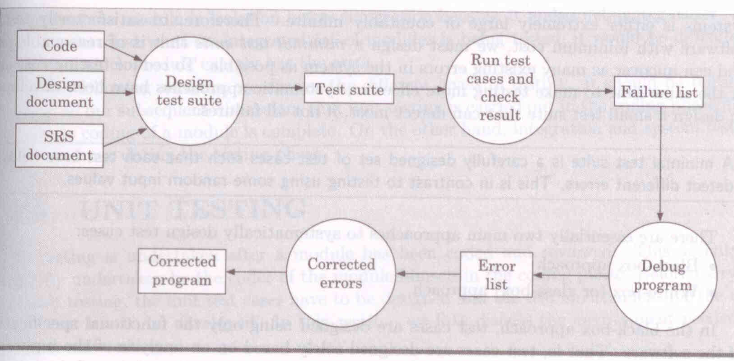

Testing involves performing the following main activities:

Test Suite design: The set of test cases using which a program is to be tested is designed possibly using several test case design techniques. (0.5M)

Running test cases and checking the results to detect failures: Each test case is run and the results are compared with the expected results. A mismatch between the actual result and expected results indicates a failure. The test cases for which the system fails are noted down for later debugging. (0.5M)

Locate error: In this activity, the failure symptoms are analysed to locate the errors. For each failure observed during the previous activity, the statements that are in error are identified. (0.25M)

Error correction: After the error is located during debugging, the code is appropriately changed to correct the error. (0.25M)

The testing activities have been shown schematically in Figure 10.2. As can be seen, the test cases are first designed, the test cases are run to detect failures. The bugs causing the failure are identified through debugging and the identified error is corrected. Of all the above mentioned testing activities, debugging often turns out to be the most time consuming activity. (0.5M)

2)A)**Cold Drinks System:** Customer places an order for certain cold drinks and makes the payment for it. The system has an employee who does sales forecast, production schedule of pending orders and other routine work. He is paid on hourly basis for the number of hours he works. The pending orders are sent to the vendor for procurement and then the payment is made to him. Draw the level 0 and level 1 DFDs for the above system. Write the data dictionary for the same. (2M)

Ans.

Data Dictionary: (0.5M)

CustomerOrder = Custid+Item+Cost+Qunatity

ProductServed = Custid+OrderNo

Payment = OrderNo+TotalAmount

PurchaseOrder = OrderNo + ReturnDate+ Item +Quantity

OrderedGoods = OrderNo+Item+Quantity

ReceivedGoods =Receivedid+OrderNo+Item+Quantity

ProductionSchedule =OrderNo+ProductionDate+Item+Qunatity

Pay =Totalpay+Noofhoursworked+RateperHour

Timeworked=Noofhoursworked

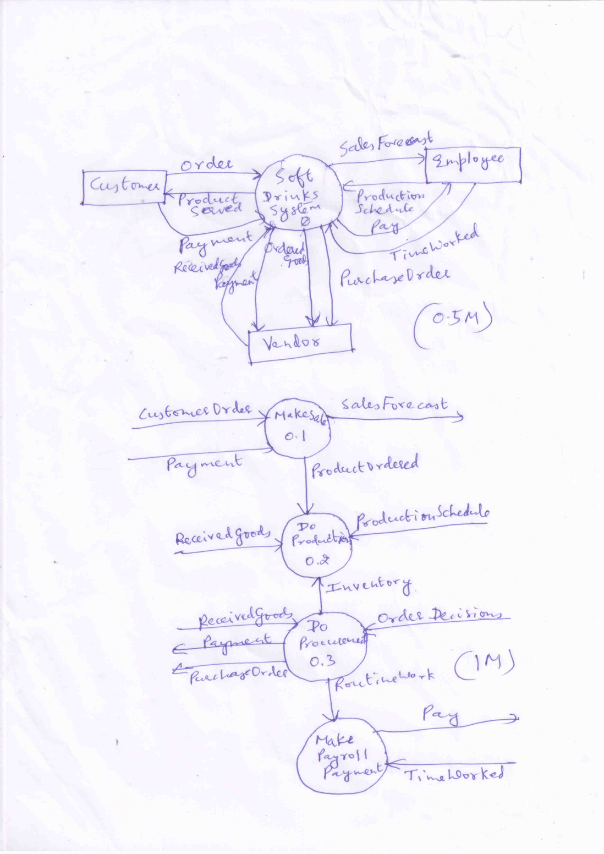

3 A) Explain any four components of sequence diagram in UML 1.X.

* Objects participating in the interaction are shown at the top of the chart as boxes attached to a vertical line and named using the syntax ObjectName:ClassName (0.5M)
* Vertical dashed line is called object’s lifeline
* A rectangle called activation symbol is drawn on the lifeline of an object to indicate the points of time at which the object is active (0.5M)
* Each message is indicated as an arrow between lifeline of two objects (1M)

Messages are shown in chronological order from top to bottom

Helps to determine the responsibilities (methods) that must be assigned to different classes

Each message is labelled with a message name.

Some control information can also be included

1. A condition

(e.g., [invalid] ) Message is sent only if the condition is true

1. An iteration marker shows that the message is sent many times to multiple receiver objects. E.g., [ for every book object] , (*)‏

3B. i) Whether the following object models are valid or not? Give reasons for your answer.

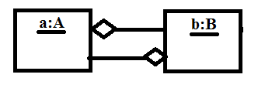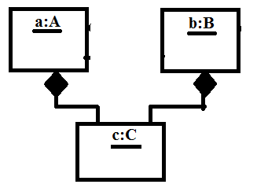

Figure 3B (a) Figure3B (b)

1. **Invalid :**

Reason:Aggregation is anti-symmetric-that is, if A is part of B, then B is cannot be part

of A. (1M)

1. **Invalid:** Violates a constraint of composition that a constituent part can belong to at most one composite. (1M)

ii) Write at least five classes that you would expect the system to handle for a program for

laying out a newspaper.

iii) Classes in a program for newspaper layout include

Page, Column, Line, Headline, and Paragraph. (1M)